**555 Timer Project**

## Objective

In this project, we will examine the charge and discharge time of a resistor-capacitor (RC) circuit. We will also learn about a simple integrated circuit (IC), 555 Timer. We will learn how the charge and discharge time of an RC circuit is used in simple designs with the 555 timers to create pulses of different duration.

We will end the project with building a circuit that once triggered turns on an LED for a time duration of our choosing. Time permitted, we will extend the circuit to one that toggle an LED indefinitely.

## Theory Overview

### Charge/Discharge Time of an RC Circuit

A capacitor is a passive device for storing electric charge. When an electric source like a battery is connected to a capacitor, the battery induces a current in the circuit which moves electrons from one of the capacitor’s plates to the other. As the charge builds up on the capacitor’s plates, the voltage across the capacitor increases until it reaches that of the battery. At that point the current and movement of charges stop.

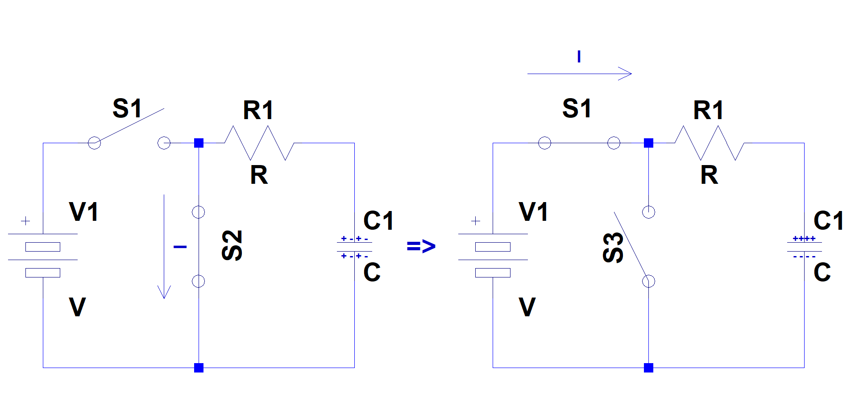

As one can imagine, the current at the moment a battery is attached to a capacitor is the largest, and as the capacitor collects more charge, the current slows down. Eventually, once the capacitor reaches its full charge, the current comes to a stop.

The charge and voltage build up across the capacitor follow a similar profile. At time 0, the charge, and therefore the voltage, across the capacitor are 0. The charge, and therefore the voltage, builds up quickly at the beginning, but as the capacitor reaches its maximum charge, the charge build-up slows down.

The time it takes to charge a capacitor is a function of how large the capacitor is (its capacitance) and how large the resistance is between the battery and the capacitor. The chart below displays the charge time of a capacitor as a function of multiples of RC.



A capacitor charges to ~63% of the input voltage after a time t63% = 1RC. It charges to ~95% of the input voltage after a time t95% = 3RC. It follows a similar profile when discharging. In other words, a capacitor discharging through a resistor loses ~63% of its charge in a time t63% = 1RC and ~95% if its charge in a time t95% = 3RC.

Electrical engineers use these time constants to design RC circuits that produce very specific time durations. In the next section we learn about one such circuit.

### 555 Timer IC

The 555 timer IC is a highly stable device for accurate time delays or oscillation. Additional inputs are provided for triggering or resetting the device if desired. In the time delay mode of operation, the time is precisely controlled by one external resistor and capacitor. For a stable operation as an oscillator, the free running frequency and duty cycle are accurately controlled with two external resistors and one capacitor.

The block diagram of the device is given below in Figure 1.

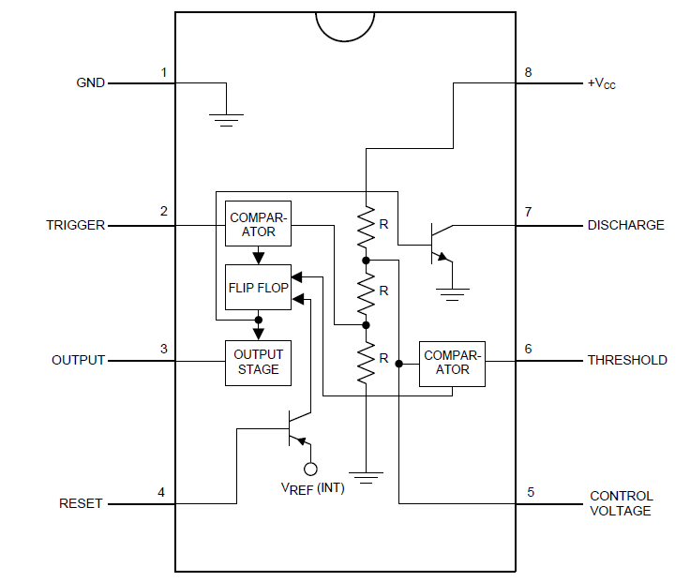

Figure - 555 Timer Block Diagram

The 555 Timer’s two “comparator inputs “Trigger” (pin 2) and “Threshold” (pin 6) control the output (pin 3) of the chip. When the Trigger pin is set to low (less than 1/3Vcc), the output of the chip is set to high (Vcc). Additionally, the transistor connected to the “Discharge” pin (pin 7) is turned on.

If, on the other hand, the voltage input on the Threshold is set to high (greater than 2/3Vcc), the output is set to low (0V) and the Discharge transistor is turned off.

The 555 Timer can be operated in two modes: 1) Mono-stable or one shot and 2) Astable or periodic.

#### Mono-Stable Operation:

In this mode of operation, the timer functions as a one-shot (Figure 2). The external capacitor is initially held discharged by a transistor inside the timer. Upon setting the Trigger input (pin 2) to less than 1/3 Vcc to, the flip-flop is set which both releases the short circuit across the capacitor and drives the output high.

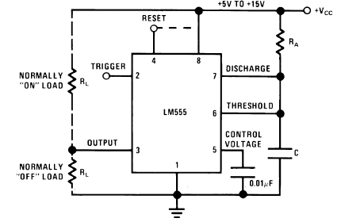

Figure - Mono-stable Operation

The time that it takes the capacitor to charge to the “Threshold” voltage, 2/3Vcc, is given by

Eq.

The comparator then resets the flip-flop which in turn discharges the capacitor and drives the output to its low state.

#### Astable Operation:

If the circuit is connected as shown in Figure 3 (pins 2 and 6 connected) it will trigger itself and free run as a multivibrator. In this mode of operation, the capacitor C charges and discharges between 1/3 VCC and 2/3 VCC. The external capacitor, C, charges through RA + RB, and therefore, the charge time is given by

Eq.

The capacitor discharges, on the other hand, through RB. Therefore, the discharge time is given by

Eq.

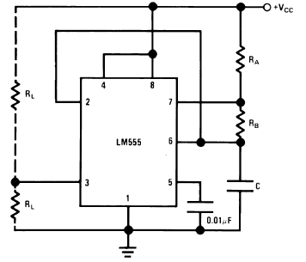

Figure - Astable Operation

Thus, the duty cycle may be precisely set by the ratio of these two resistors.

In the next section, we will go through step by step construction of the mono-stable circuit.

## Circuit Construction

Using a 555 Timer IC, resistors, capacitors and an LED, we will construct a simple timing circuit that will turn on an LED for a time duration of our choosing. The following steps will walk us through determining the R and C values and the construction the circuit shown in

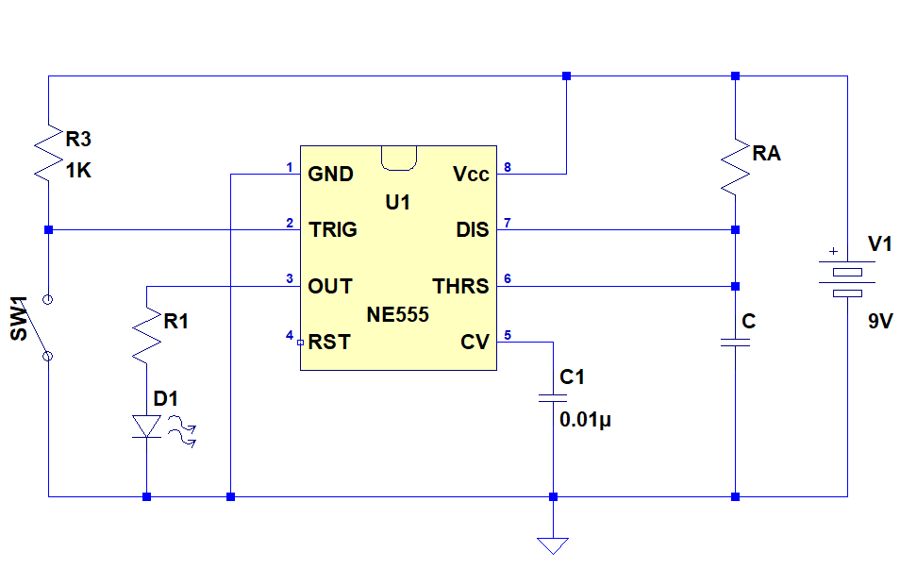

Figure - 555 Timer Circuit

### Connecting the LED

We would like for the LED to turn on when we trigger the 555 Timer chip. Since the output of the chip is high (at Vcc) when triggered, we will connect the LED and its current limiting resistor from the output (pin 3) to ground.

1. Determine the current limiting resistor for your LED.
   1. Record the turn on voltage (forward voltage) of your LED
   2. The output of the 555 Timer when triggered will be at Vcc - 2 = 7V, at which point, we would like If = ~5mA of current to flow through the LED. Determine the current limiting resistor using Ohm’s Law

### Setting the Pulse Duration

In this portion of the project, we will determine the R & C values for the timer circuit such that the LED is turned on for the time duration of our choosing when the 555 Timer chip is triggered.

1. Pick a time duration for which the LED should remain on
2. Recall that the time duration for which the output of the 555 Timer chip is high (Vcc) is the same as the time that the capacitor is charged through RA and is given by Eq. 1
3. Using this equation, we can solve for either RA or C. Let’s solve for RA.
4. Now, let’s pick a convenient value for C
5. Now we can solve for the value of RA

Construct the circuit in Figure 4 with the resistor and capacitor values above and test the circuit.

### Observations

1. Is the circuit behaving as you expected? If not, why?
2. How would you change circuit to have the LED stay on for twice the amount of time?
3. What do you think is the maximum time duration you can make the LED stay on?